⭐ Supernova BIA Externship — Final Presentation Prep Guide
Every student must return fully prepared with a draft version of their final presentation story and supporting analysis. This preparation is essential because our final week will be focused only on deck assembly, refinement, and dry-runs — not raw analysis.

🎯 Final Presentation Requirements
Regardless of whether you completed 1 topic, 2 topics, or all 4 topics, every student must prepare:
- ✅ A 4–7 pages analysis deck
- ✅ A 6-minute verbal presentation
- ✅ A clear storyline supported by your analysis
Your presentation must be data-driven, supported by your own answers to the Starter Questions (PDF) provided in Week 2. You will not be graded on how many topics you completed. You will be evaluated on clarity, insight, structure, accuracy, and storytelling.

📘 How to Prepare Your Final Story Over the Weekend
Your job during the break is to:
- Review your analysis from the topics you’ve completed
- Re-read the starter questions and your answers
- Identify a storyline you can explain in 6 minutes
- Choose 4–7 exhibits (pivot tables, charts, insights)
- Draft a rough outline of your final presentation slides

📌 The Three Story Paths (Choose One)
Students fall into 3 categories. Below are the expectations for each, plus new data-driven examples based on the dataset.

⭐ A. If You Completed ONLY 1 Topic
(Example: Premium OR Decline OR LLM OR Quote Journey)
You must create a deep-dive story from your single topic. Your 4–7 pages should include:
- What the dataset tells you
- What patterns you found
- What these patterns mean for Supernova
- Your interpretation & Recommendations

Examples of Strong Single-Topic Stories

1. Quote Journey / Funnel Story Examples
- The "Revenue" Bottleneck: "Stage 2 (Revenue) is the single biggest drop-off point (644 users lost). Moving this sensitive question to later in the funnel could retain ~12% more users."
- The "Place ID" Trust Factor: "Users with a valid Google Place ID complete the quote 54% of the time, compared to only 34% for those without. We should prioritize auto-filling business data to boost completion."
- The Geographic Gap: "The funnel is broken in Western Canada. Ontario converts at ~30%, while Alberta lags at ~16%. We need to investigate if the form validation is failing for non-Ontario addresses."

2. Premium-Only Story Examples
- The "Silent" Revenue Loss: "While we focus on bound policies, there is $17.5M in 'Zombie Revenue'—quotes that reached 'Complete' status but failed to generate a premium value."
- High-Value Inconsistency: "Real Estate and Hospitality are our highest completion sectors, yet they have the highest variance in premium output. Standardizing pricing here is the quickest win."

3. Decline / LLM Story Examples
- The "Safe" Rejections: "The LLM is rejecting 1,700+ users who actually completed the full journey but received no specific error log. These aren't risky clients; they are system errors."
- The Mobile User Disadvantage: "Source App 'LR' (likely mobile) triggers significantly higher validation errors than desktop users, suggesting our validation rules aren't mobile-friendly."

⭐ B. If You Completed 2 Topics and Want to Combine Them
You must combine insights into a multi-layer story. This often produces some of the strongest presentations.

Examples of 2-Topic Storylines

Premium + Journey (The "Value at Risk" Story)
- The Insight: "We aren't just losing random users; we are losing high-value ones."
- The Data: "By combining the Funnel Drop-off counts with Average Premium ($8,620), we can see that the drop-off at Stage 6 (Contents Coverage) costs Supernova $5.5M in potential revenue—more than any other technical stage."

LLM + Journey (The "Tech Barrier" Story)
- The Insight: "Technical validation rules are actively hurting our user experience."
- The Data: "Users with missing Google Map links are 2x more likely to be rejected by the LLM and 20% more likely to drop off before Stage 4. Fixing the map API would solve both problems."

Decline + Journey (The "False Hope" Story)
- The Insight: "The system is lying to users about completion."
- The Data: "2,030 users reached Stage 10 (Complete Quote), yet have NaN premiums. To the user, they finished. To the business, they are invisible. This 'Zombie' cohort represents a massive hidden failure rate."

⭐ C. If You Completed ALL Topics (The CEO Story)
You must deliver a full 360° business analysis across: Premium → Decline → LLM → Journey.

Examples of Full-Stack Storylines

Full-Stack Story Example 1: "The $30 Million Leak"
"Across the lifecycle, we lose value at three critical points:
- Friction: Asking for 'Revenue' too early kills 12% of traffic.
- Tech: 2,000 'Zombie' quotes finish the journey but fail to generate a premium due to LLM errors.
- Geography: Alberta and BC are underperforming Ontario by half.
Conclusion: The total opportunity cost of these three leaks is ~$29.9M. Fixing just the 'Zombie' bug would immediately recover $17.5M in potential pipeline."

Full-Stack Story Example 2: "Quality over Quantity"
"We have high traffic (5,800 starts) but low quality data capture.
- Users without Place IDs fail the LLM checks.
- Users with valid Place IDs finish at a 54% rate.
- Recommendation: Stop letting users manually type addresses. Force Google Place ID selection at Stage 1. This will reduce drop-off, increase LLM pass rates, and standardize premium calculation."

📄 4. Slide Expectations (4–7 Pages)
Each deck must include:
Slide 1 — Problem Statement
- "What question did you investigate?"
- Example: "Why are we losing 60% of users before they get a price?"
Slide 2-5 — Key Insights & Exhibits
- Top findings from the dataset(s).
- Suggested Visuals: *
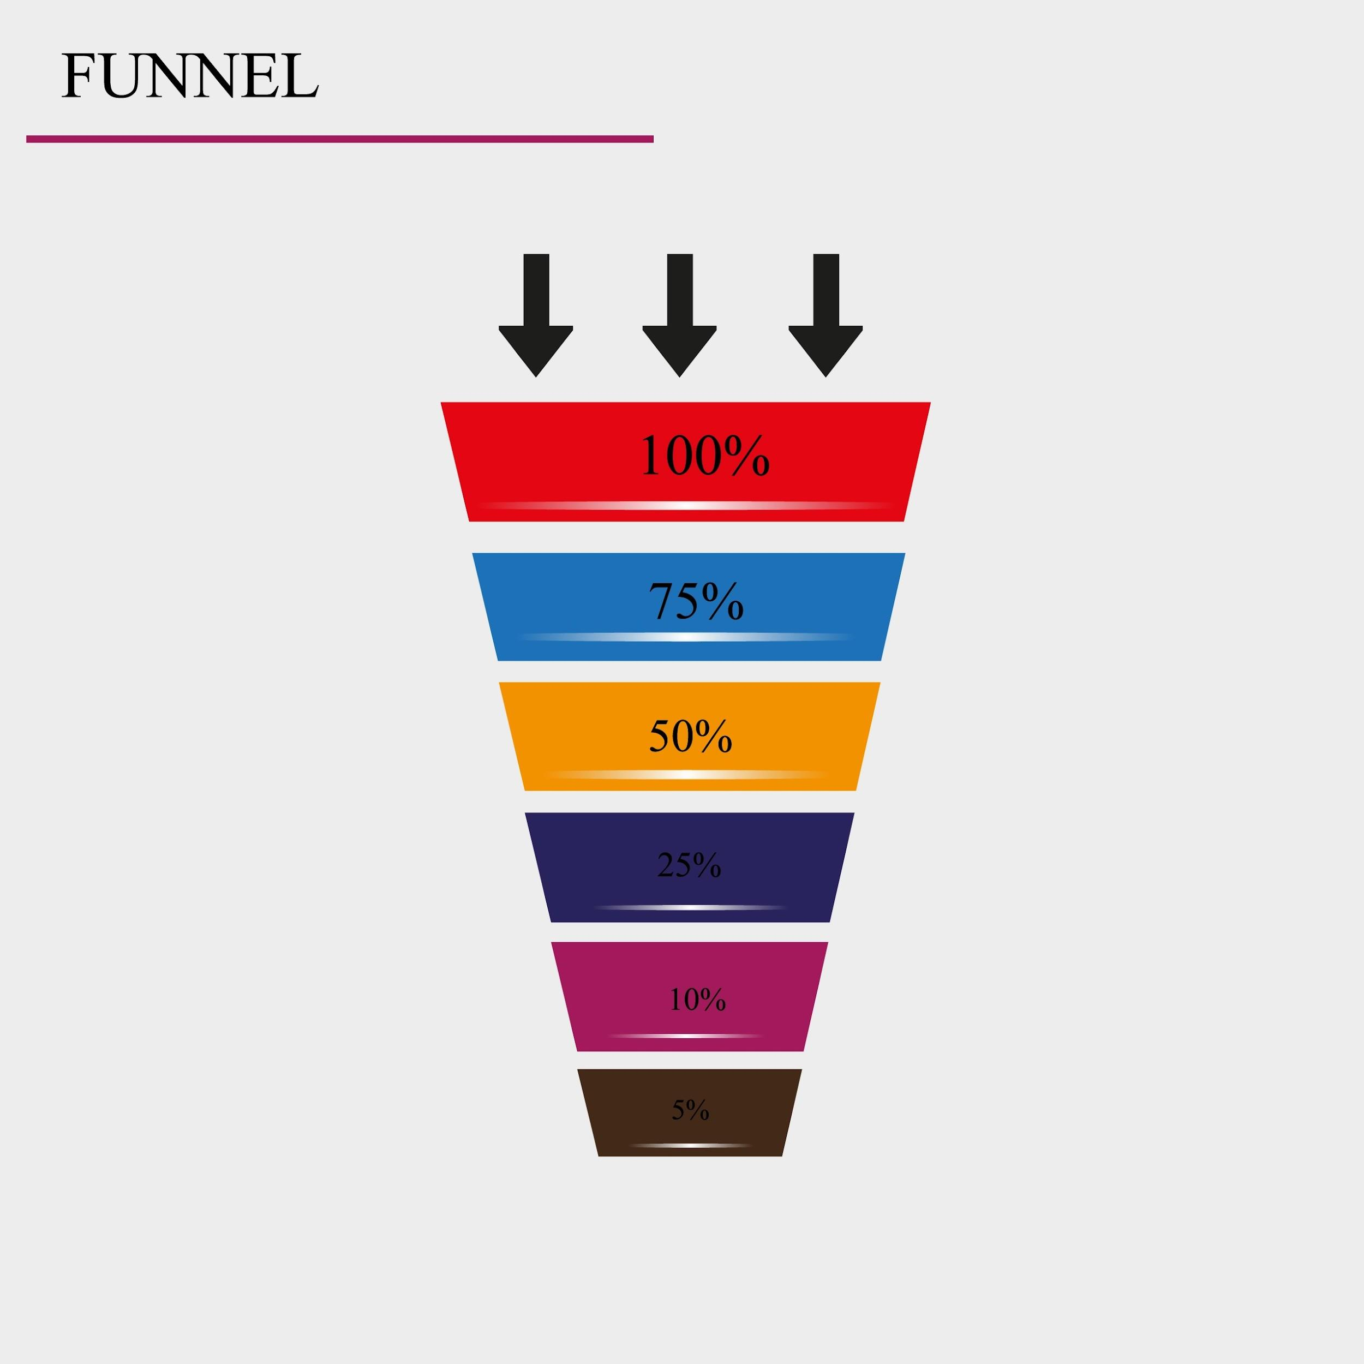
Shutterstock
Bar chart showing user count dropping from Stage 1 to 10. *
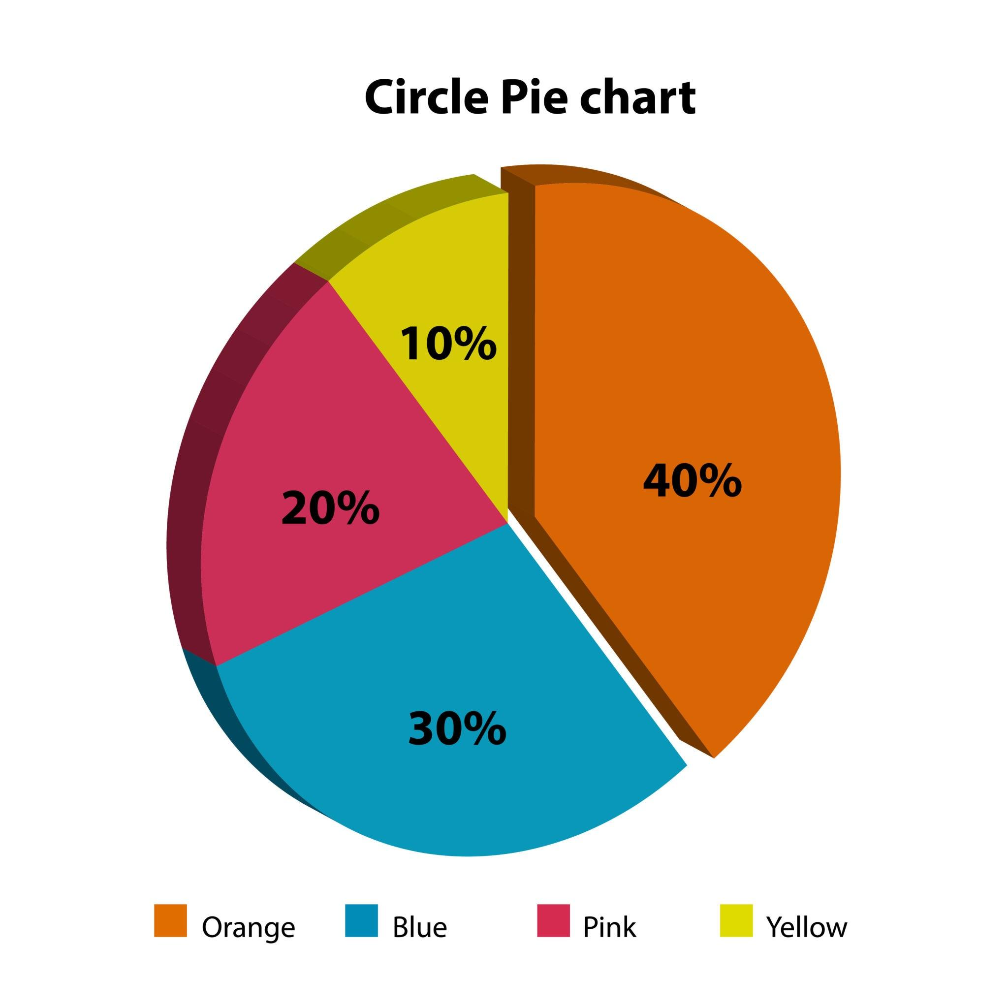
Getty Images
Breakdown of "Complete" users vs. "Zombie" users. * Completion rate by Province (Ontario vs. Others).
Slide 6 — Interpretation & Recommendations
- What the findings mean for Supernova’s business.
- Actionable Next Steps: (e.g., "Move the Revenue question to Stage 8," or "Audit the Alberta pricing engine.")

🧭 5. Final Story Checklist
(Students Should Answer These Before Returning)
- [ ] What is the central message of my presentation (1 sentence)?
- [ ] Do I have specific numbers to back it up (e.g., "$17M loss," "12% drop-off")?
- [ ] Do I have at least 4 pages of meaningful analysis?
- [ ] Does my story explain what (the data), why (the cause), and so what (the business impact)?
- [ ] Can I deliver this story clearly in 6 minutes?

